What’s In It For You—Benefits?

Annual Contribution: 3 year commitment preferred

Government Partner ($5,000+)
- Logo on literature
- Hot Link listing recognizing partnership level published in monthly e-Newsletter with link to your website—traffic can be measured.

Platinum Partner($2500)
- Hot Link Listing recognizing partnership level published in monthly e-Newsletter
- Logo with a link to your website on Nebraska City Area EDC’s website

Gold Partner ($1,000)
- Listed in monthly e-Newsletter

All Six Partnership Levels Will Receive...
- Exposure on the Nebraska City Area EDC’s website Partnership Page with a link to your website
- Access to “Economic e-Notes”, a monthly e-Newsletter containing economic development issues and activities impacting the future of our community and area.
- Recognition as an involved and supportive partner for development of Nebraska City and Otoe County. Prospects view partnerships as indicators of development support and growth.
- Recognition as a Partner at the Annual Partner & Industry Appreciation Social
- Notification of upcoming workshops, events, and training seminars to assist in partner/business development.
Partnership Investment Levels
Annual Contribution: 3 year commitment preferred

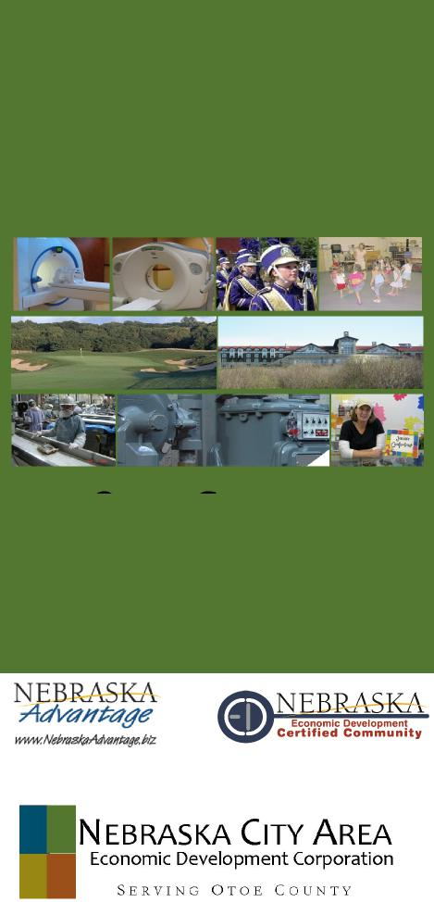
City, County & Our Partners Working Together
2017-2018
PARTNERSHIP
INFORMATION
Government Partner | $5,000+
Platinum Partner | $2,500
Gold Partner | $1,000
Silver Partner | $ 500
Bronze Partner | $ 250
Affiliate Partner | $ 100

A fillable Partnership Application Form is available online at www.NebraskaCityareaedc.com or request a form by calling the Nebraska City Area EDC Office at
(402) 873-4293.

Otoe County: A Place to Grow
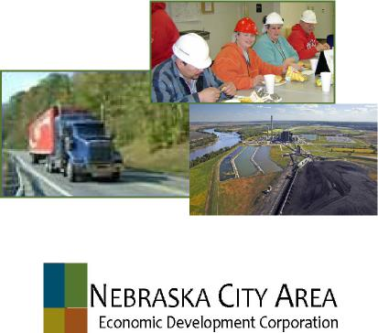
Otoe County:
A Place To Grow
Building On Our Economy
123 So. 8th St., Ste. 7
Nebraska City, NE 68410
P: 402.873.4293 |

http://www.nebraskacityareaedc.com/

Who We Are?  Nebraska City Area Economic Development Corporation (Nebraska City Area EDC) is a 501 (c) 6 not-for-profit corporation primarily dealing with the economic development needs of Nebraska City and Otoe County area.  Mission Statement  The mission of our organization is to promote the attraction, creation, retention, and expansion of businesses and to enhance our quality of life in Nebraska City and Otoe County.  Our Primary Purpose  Is to provide economic development services that focus on the county’s priorities, supported by county-wide business and industry. We strive to meet these needs—by providing diverse job opportunities and increasing capital investment and growth of county-wide valuation—by focusing our efforts on industrial recruitment and retention, business development, entrepreneurship, leadership development and downtown redevelopment. |  | What Is Our Role—Our Priorities?  - County-wide leadership in economic development  - Identifying and promoting our county-wide opportunities  - Identify, develop and market potential development sites in Otoe County  - Actively assist and recruit potential employers who create quality jobs and who are best suited to the resources of Otoe County  - Assist current business and industry with retention and expansion needs  - Identify, recruit and assist entrepreneurs in the area  - Work with local governmental entities on future development, land use and infrastructure needs  - Educate the public about the importance of economic development to the future of the area  - Assist with the growth of a quality, skilled local workforce  - Business networking  - County-wide economic statistical data and surveys  - Project facilitation leading to development investment and job growth  - Work on a regional basis to promote the resources and quality of life in Southeast Nebraska | 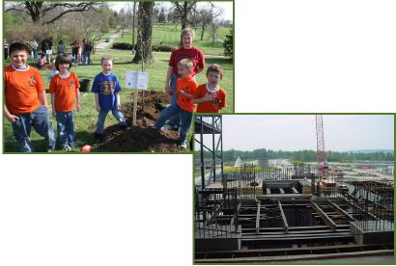
Who Should Become A Partner?
- Agriculture
- Computer Technology
- Construction
- Education
- Energy
- Engineering & Architecture Firms
- Finance & Insurance
- Individuals interested in Economic Development
- Local Government
- Manufacturing
- Non-profit Organizations
- Professional
- Property & Real Estate
- Retail
- Transportation
- Tourism & Hospitality
 | 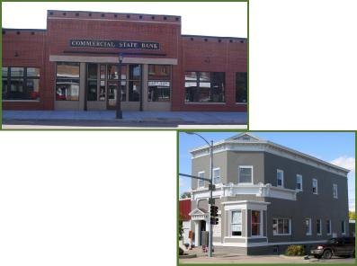
 |  |  | 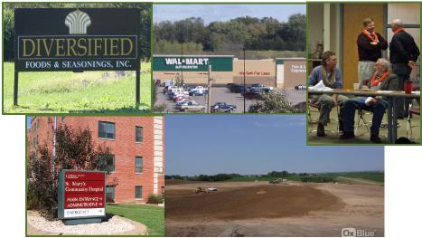
 |  | 